Leader & speaker sec.
Joyce Loveridge
01425 837789
Ja.loveridge@icloud.com

Secretary.
Val Wheeler
01202 419727
V&G@hotmail.com

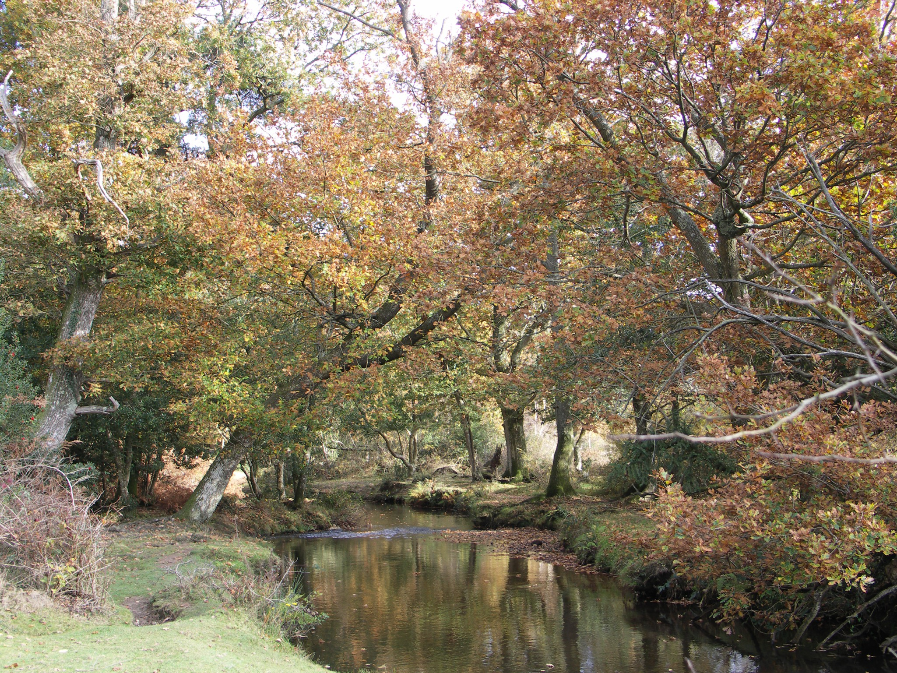

Barnabas Fellowship

Autumn Term 2019

September
10th Communion —- Robin Wood.

17th Mary Randell. —- Feeding The
Homeless.
24th Liz Webb —- Japan update
Japan behind the Cherry
Blossom

October
1st. Eddie Martin —-Myra’s Wells
Safe Water - Living Water.

8th. Mike Mellor —- ‘Not Ashamed’

15th Chris Stratton —- The Leprosy
Mission.
22nd. Informal—- Bible-a-Month.

29th Alistair Mc Gregor—-Open Doors.

November
5th. Andrew Varney —- A Christchurch
Constable - answered prayer.

12th. Informal —- Bible-a-Month.

19th. Jamie Campbell —-SASRA update
Evangelism among the forces.

26th. David Hilborn —- Principal
Moorlands Bible College.

December
3rd Christmas Meal —Sharron Prior
And Team.

10th. Christmas Carol Service.

